BURUNDI FREE METHODIST CHURCH
INTERNATIONAL CHILD CARE MINISTRIES-HCD
CASE STORY
Every month Burundi International Child Care Ministries team visits the small family projects that are being implemented by families of church leaders in order to follow up the ongoing of those projects. Those projects are mostly farming and life stocks, business and raising animals.
For the fourteen projects we visited in Cibitoke area one of the forty four districts we have in the Burundi Free Methodist Church, we were very much encouraged because the family projects are giving very good results. We found some growing rice as their projects, others raising goats, chickens and pigs and others beans and corn. The animals are multiplying amazingly, the crops are very nice to see and harvest is very good and big. Below are pictures with a brief description of those different family projects.
Picture no 1
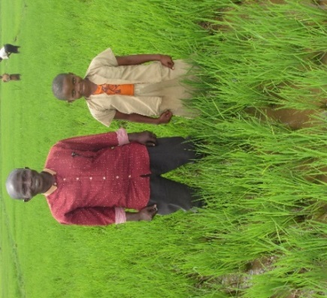
For BU105-09595 Florence Iteriteka, a sponsored child, we witnessed a garden of rice from which the family expects to have a very good and big harvest. The family is very happy and plans to get food to nourish children in the family and money for cloths and other requirements. The challenge they have is to get money for enough fertilizers on time.

Picture no 2
BU105-09597 Lievin Igiraneza is another sponsored child. When we visited the family, Lievin was at school and couldn’t join us. The family planted mandarin orange trees and they expect to harvest in three years. Most of the fruit trees are still so young and others are growing.
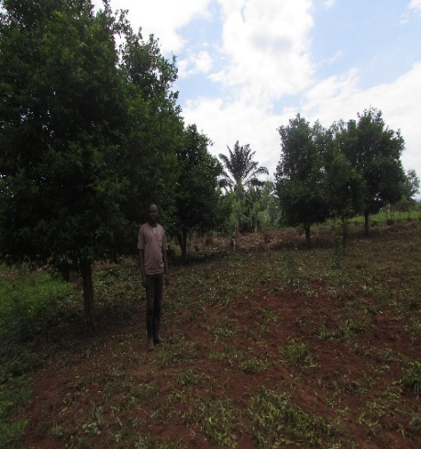
Picture no 3
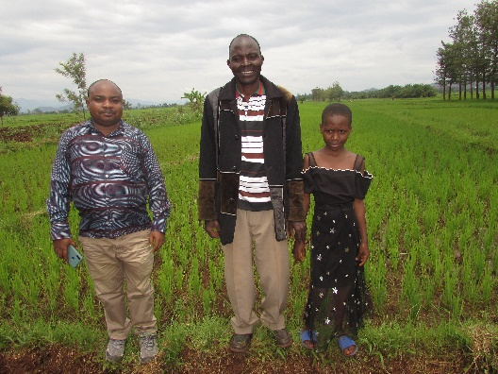
BU315-09811 Belyse Beline Igirubuntu family started by raising a pig. After a certain period, the pig gave birth to 8 piglets which were sold and the money was used to start another agricultural project. They grew rice in a big field that you see behind the child, her father and ICCM national coordinator. This family is implementing well projects and using well the money they receive for their family projects. The harvest they expect to get from the garden of rice will have a cost of around 3000.000 Burundi francs. For now, the family is living well and children are comfortable, well-nourished and learning.
Picture no 4
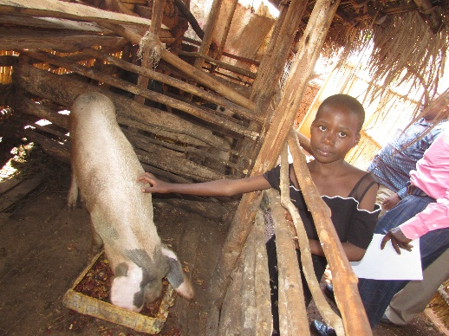 BU315-09811 Belyse Beline Igirubuntu (same as above)
BU105-03997 Diane Nishimwe is an ICCM sponsored child. The picture shows Diane with the growing goats as her main project. She said that they bought one goat and the latter gave birth twice, one of the two baby goats was sold in order to meet some family needs.
Picture no 5
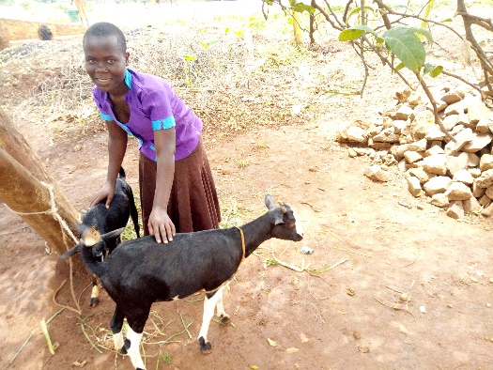
Picture no 6
BU105-03999 Janvier Sinzinkayo who has been sponsored and benefited funds for small family project. On right is Janvier and on left is his mother. They have two very big pigs. One is a male, another is a female.
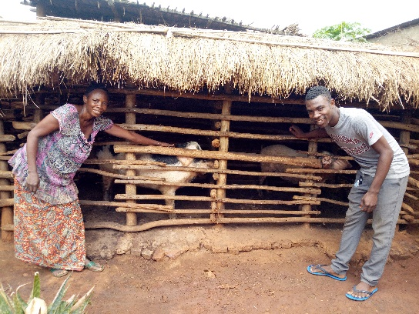
Picture no 7
BU105-02892 Angelique Uwizohoza and BU105-02893 Jeanine Tuyisenge are two sponsored children in one family. This family is blessed with the benefit of funds for small family project. As two children who are sponsored in this family, their main projects are raising pigs, chicken and growing rice.

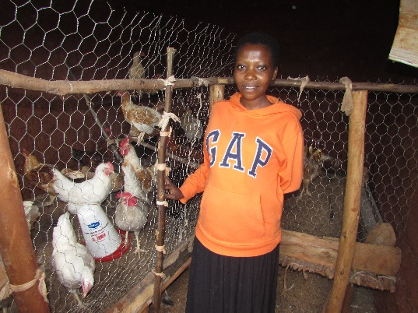
Picture no 8
The chickens are beautiful and productive; they are giving organic fertilizers which help the family to cultivate beans, potatoes, bananas, etc.
You can see also the harvest of rice as food for nourishing children and provide for other needs in the family. The father told us that now with the projects there is no problem of food, clothes or other requirements in the family.
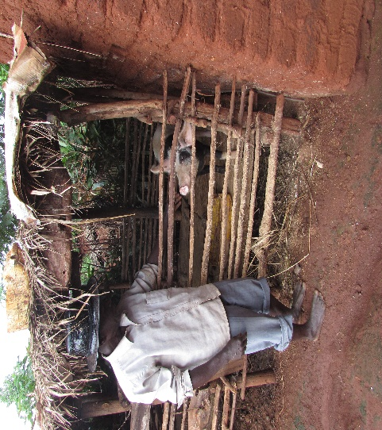
Picture no 9
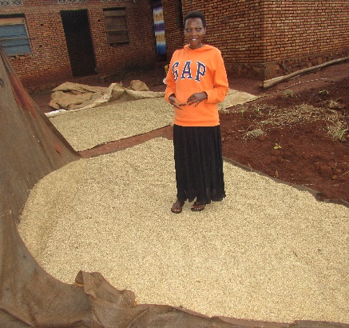

Picture no 10
It was very interesting to look at BU105-03986 Elysee Nimbabazi garden of beans and corn. The crops are amazingly very nice to see and harvest will be very good and big.
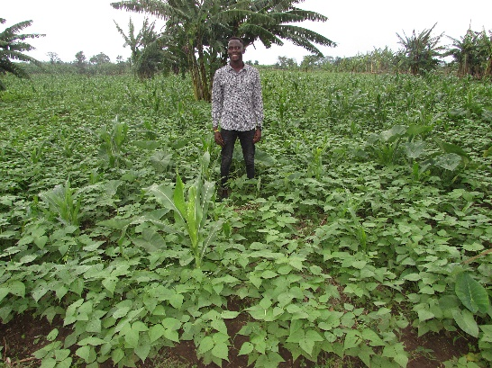

Let us just conclude this case story by saying that the visited families mentioned some challenges they face when implementing their small family projects. As the team doing follow up, we tried to give them ideas on how to overcome those challenges.
May the Lord continue to bless all sponsors involved in financing children and their families in those family projects.
Augustin/NC

